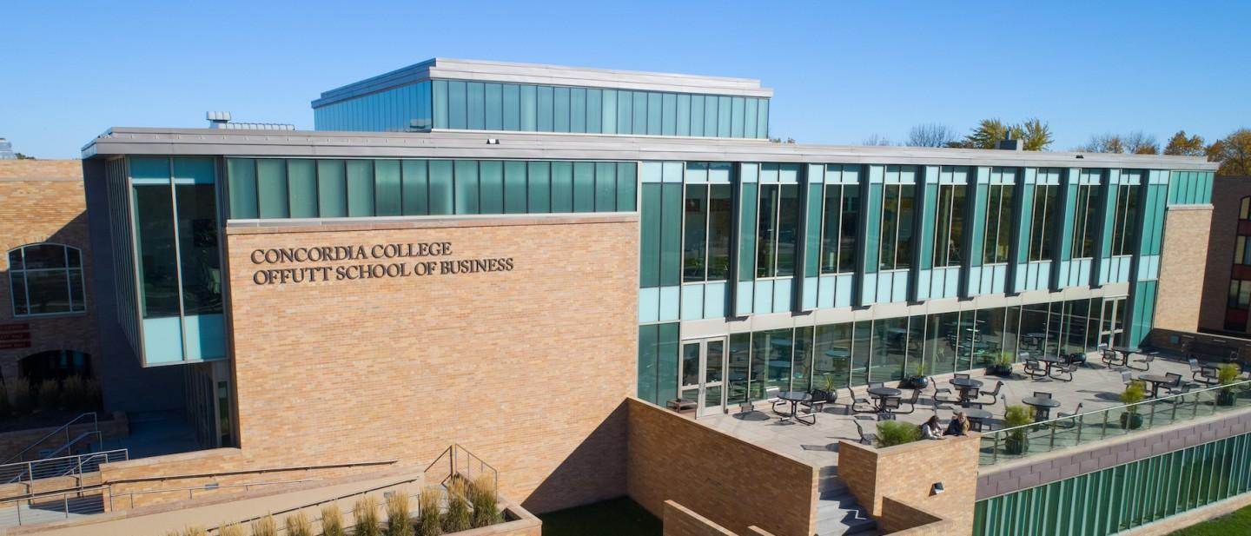

| CobberEats |
| --- |

| Course | **CSC 311 – Mobile Applications Development** |
| --- | --- |
|  | |
| Team Name | **AMEX** |
|  |  |
| Team Members | **Mariana Martins Carvalho** |
|  | **Elicia Powell** |
|  | **Xander Spray** |
|  | **Andy Mera Morocho** |

| Executive Summary |
| --- |
| **Your executive summary should resemble an elevator pitch: your motivation is to quickly persuade a decision maker to get involved in your project.** |
| * **What is the purpose of your project; what problem(s) does it address?** * **Why is your project important; why is it relevant? (NOTE: not in terms of the class to get a good grade)** * **Who could your project help; who is your audience or customer?** |
| Very frequently students will spend their swipe on meals they do not enjoy because they haven’t checked the menu of the day. There aren’t many accessible and quick ways to see the menu and also to gauge whether the food is good or not. That’s why we are offering CobberEats, an app where students can upload their meals and rate it accordingly - that way you know if you should eat on campus or get food somewhere else. |

| Background and Problem History |
| --- |
| * Explain the problem domain and relevant background information about your project * Provide a brief history of the problem; when did it start? What attempts have been made to solve it? * NOTE: Think in terms of your PROJECT, not in terms of this class |
| Anderson Commons menu is posted outside DS and also online, however, there is no information whether the food is good or not. It is also not an efficient way for students |

| Solution |
| --- |
| * How does your team plan to solve the problem? * What makes your approach different from other solutions? |
| Our mobile application aims to make it easier for students to know what food is being provided and its quality on a daily basis. This application also streamlines connecting students together through other students' feedback on the provided meals. This makes sure that students are more informed so they can make decisions that meet their needs. Concordia does have a website containing a daily menu, but they don’t always update the meals. Since our app relies on student engagement, as long as people are eating at DS every meal is uploaded. |

| Project Deliverables |
| --- |
| * What will be the “product” of your team’s project? What documents will you create? |
| * A functional Android app built using Kotlin.   + Features include user authentication, meal postings, ratings, and a maybe comment section.   + Source code repository hosted on GitHub   + Technical documentation   + User guide: written or video walking through the app |

| Success Criteria |
| --- |
| * How will your team define success? What aspects of your project can you quantify to objectively measure success? * NOTE: Think in terms of your PROJECT, not in terms of this class |
| We can consider our project a success if:  - Users are able to make an account and log in  -Users are able to make a post and respond to others  - Users posts can seen by other users  - Users will be able to rate posts |

| List of Required Project Resources and Materials |
| --- |
| * What resources (books, websites, data sets, problem domain information sources, software, etc.) will be / have been required to complete your project? |
| * Concordia’s daily menus page * Youtube * Kotlin textbook * Android app textbook |